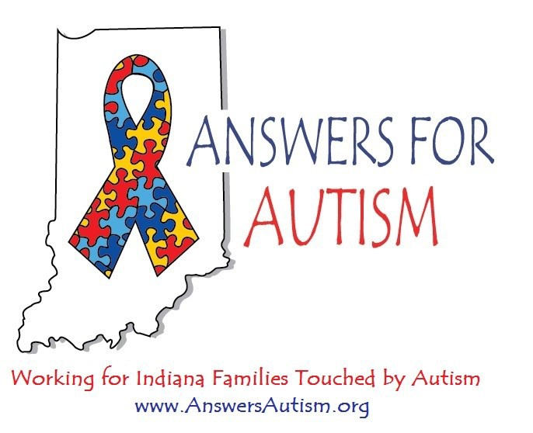

Family Fun Festival

Formerly The Answers for Autism Walk

No registration required. Donations will be accepted.

Saturday, September 16
10 AM to 2 PM
Coxhall Gardens, 11677 Towne Rd. Carmel, IN 46032
Balloon Release – Meet up groups – Food vendors
– Raffle for Answers for Autism T-shirt quilts

Autism Merchandise – Inflatables – Sensory Fun Tent –
Face Painting – Yoga Class – Miniature Golf

More information at our Facebook page – Use your QR Code reader to go directly there:

